## ***1.******Sprint1 Review***

| Functional | Register | Register with email and password | Completed |
| --- | --- | --- | --- |
| Login | Login by email and password | Completed |
| Login authentication | The account needs to be activated by email verification. | Completed |
| Protect route | The access of certain pages needs user login. If not logged in, it should jump to login page | Partial completed* |
| Password reset | Enter the old password and its new password | Partial completed* |
| Update Personal Profile | Update information about users (only for standard users, they can update their contact info, not role) | Completed |
| Profile image upload | Update profile image with a new pic | Partial completed* |
| Display personal profile Info | Display info | Completed |
| Search | Search user via name | Completed* |
| Non-functional | Server Build | Based on scalability | Completed |
| Set up tech tool | Development tools and communication tool | Completed |
| UI Design | Login; Register; Search Page; Profile page; Change profile Page;  Front Page (where users can select their identity to login) | Completed |
| Theme color | United Blue and orange | Completed |

* ***Not Scheduled***

| Separate login entry | Admin and standard user login entry | Completed |
| --- | --- | --- |
| Profile image upload | Update profile image with a new pic | Not completed* |

* ***Summary of requirements that are partially completed*** 
  + Frontend:
    - Update profile (email may not be reset), for standard user, it may only change contact details
      * Employee: phone Number, notes and password
      * Admin: role, product owner, value stream, scrum team
    - Combine search front page with search functionality (backend)
    - Update profile image front end
    - Display profile image properly (still have bugs)
  + Backend:
    - Protect route debugging (if failed with login status, jump to login page)
    - Password reset and authentication before reset
    - Update profile image

## ***Team Sprint 1 comments***

Ultimately, our team successfully finished 85 per cent of the work we scheduled to complete in sprint 1. Since four members of ours are new to react, nodejs and javascript, we are quite satisfied with this outcome. As our knowledge gradually builds through self-learning, our communication and collaboration, we are confident we can complete scheduled work in the next sprint. We would be more careful on time management and workload distribution to ensure both quality and efficiency of our work.

## **2.** **Sprint 2 Goal Setting**

|  | **As a <Role>** | **I want to <Do something>** | **So that** | **Priority** |
| --- | --- | --- | --- | --- |
| Functional Requirement | Admin | Delete an account | Deactivate left employee’s account | High |
| View all users in the database | At Admin’s Home page (after login) | High |
| Edit specific user’s info (only role, …) | Update Info | High |
| View specific user’s profile info | Check if update works/ current profile info | Medium |
|  | Logout |  | Medium |
| Standard user | Get search result | Pick user from result page | High |
| Logout |  | High |
| View selected user’s profile | View only | High |
| Add it to contact list | Find him/her in our list | Medium |
|  |  | Logout |  | Medium |
|  |  | **Task** | **Notes** | **Presenter** |
| Non-Functional  Requirement |  | deployment | Use Heroku | David & Karlie |
|  | Testing |  | Max |
|  | Design diagrams |  | Vincci & Lydia |
|  |  | Loading animation |  | frontend |

**Summary:**

Both frontend and backend should implement these.

* Client meeting
* Sprint retrospective

***To do List: (W9)***

| As a <role> | Task | Category | Status | Time |
| --- | --- | --- | --- | --- |
| Standard user | **Search result** | **Frontend** | Completed | **Wednesday** |
| **View specific user’s profile** | **Frontend & Backend** | Completed | **Thursday** |
| Password reset | Backend | Completed | High |
| Loading animation | Frontend | Completed |  |
| Logout | Frontend & Backend | Completed |  |
| Admin | Home page (after login) | Frontend |  |  |
| edit user info page | Frontend & backend |  |  |
| View specific user’s profile | Frontend & backend |  |  |
| Register | Frontend & backend |  |  |
|  | Logout | Frontend & backend |  |  |
|  | **Deployment** | **Other** | **Heroku** |  |
|  | **Design diagram** | **Other** | **Completed** |  |
|  | **Testing** | **Other** |  |  |
|  | **Meeting Minutes** | **Other** | **Completed** | **Almost done** |
|  | **Trello** | **Other** | **Vincci** |  |

Bug:

* Search Icon

**Reuse Planning**

| **Component** | **Version** | **Notes** | **Documentation** |
| --- | --- | --- | --- |
| React | 17.0.2 | Front end framework | <https://reactjs.org/> |
| Node js | 16.7.0 | Node.js is an open-source, cross-platform, back-end JavaScript runtime environment | <https://nodejs.org> |
| Material UI | 4.12.3 | React component for faster and easier web development | <https://mui.com/zh/> |
| react-router-dom | 5.2.1 | Routing webpages (e.g. redirect, navlink, etc) | <https://www.npmjs.com/package/react-router-dom> |
| Jason Web Token | N/A | Used for user authorization | <https://jwt.io/> |
| Js cookie | N/A | HTTP cookies are small blocks of data created by a web server while a user is browsing a website and placed on the user's computer or other device by the user’s web browser. | <https://github.com/js-cookie/js-cookie> |
| Passport | N/A | A comprehensive set of strategies support authentication using a username and password | <http://www.passportjs.org/> |
| Axios | 0.21.1 | make HTTP requests from node. js the browser | <https://www.npmjs.com/package/axios> |
| Adobe XD | 16.0. 12 | Design and draw UI prototypes | <https://www.adobe.com/products/xd.html> |
| Protect-route | N/A | Protected routes allow us to ensure only logged in users can access certain parts of our site that may contain private user information. | <https://dev.to/olumidesamuel_/implementing-protected-route-and-authentication-in-react-js-3cl4> |
| MangoDB | 4.4 | MongoDB is a source-available cross-platform document-oriented database that used to store data of our web application | <https://www.mongodb.com/> |
| Notability | N/A | Hand drawing diagram and note taking | <https://apps.apple.com/us/app/notability/id360593530> |
| Draw.io | N/A | Draw diagram digitally | <https://app.diagrams.net/> |
|  |  |  |  |

**Design Diagrams**

* + *Broad Planning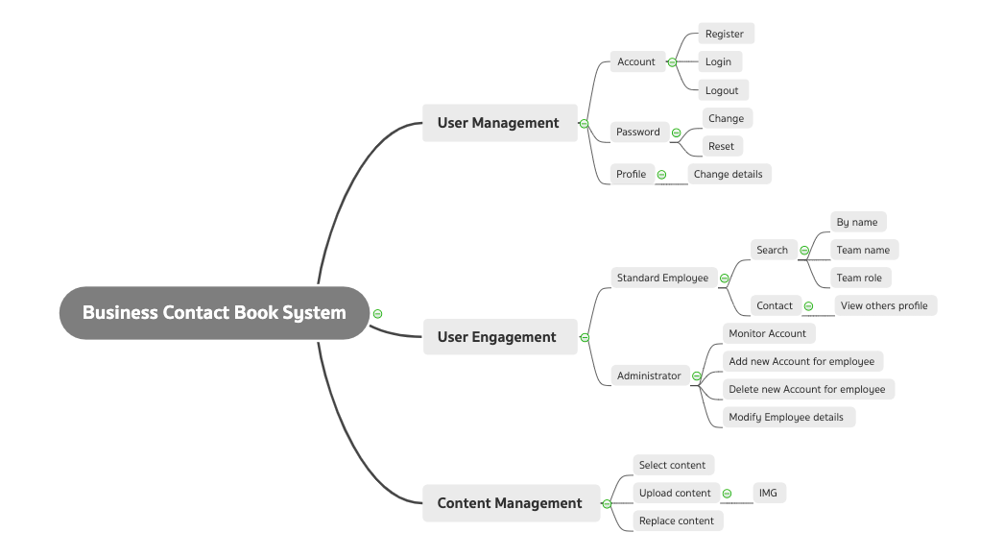*
  + *Domain Model*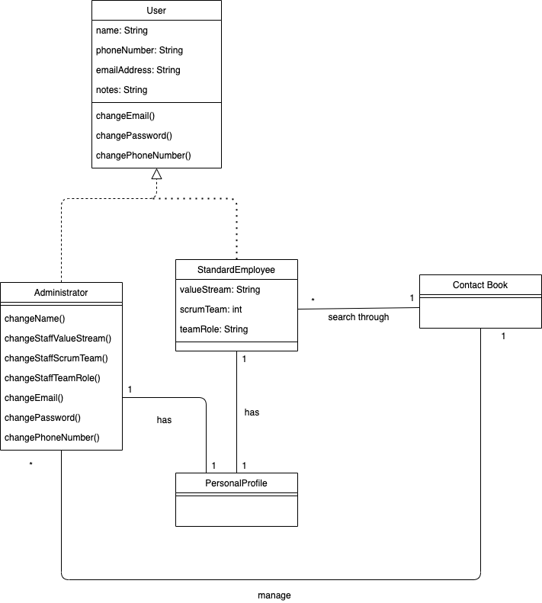
  + *Use Case Diagram*

